Test plan - savings app
Test No. | What is being tested? | Data (user_id, ammount) used? | Expected outcome | Actual outcome | Notes
1 | View a balance for a user | get_user_data(1, conn) | 132.0 |  | Pass
2 | View the balances for all users | No data | user_id balance  --------- ---------  1 132  2 15  3 126  4 96  5 75  6 15  7 78  8 117  9 135  10 87 |  | Pass
3 | Add funds for a user | def add_funds(1, 15, conn) | Record for user: 1 updated - 15 added  True  user_id balance  --------- ---------  1 147 |  | Pass
4 | Remove funds for a user (funds must not go below 0) | remove_funds(1, 15, conn) | Record for user: 1 updated - 15 removed  True  user_id balance  --------- ---------  1 117 |  | Pass
5 | Add a new user with a balance of 0 | def add_new_user(11, conn) | user_id balance  --------- ---------  11 0 |  | Pass
6 | Remove a user | remove_user(3) | User with ID 3 removed |  | Pass
7 | Add a new user | def add_new_user(1, conn) | User already exists | 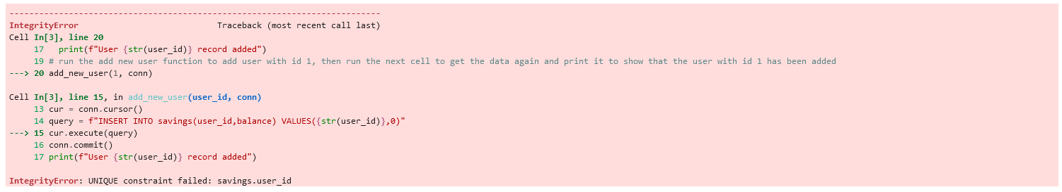 | Need to add validation of user_id to check if already exists
8 | Exit the app | exit_app(conn) | Exiting app... |  | Pass

